VMs creation and Backup and Restore

1 .I created virtual networks ,storage account and recovery service vault using power shell.

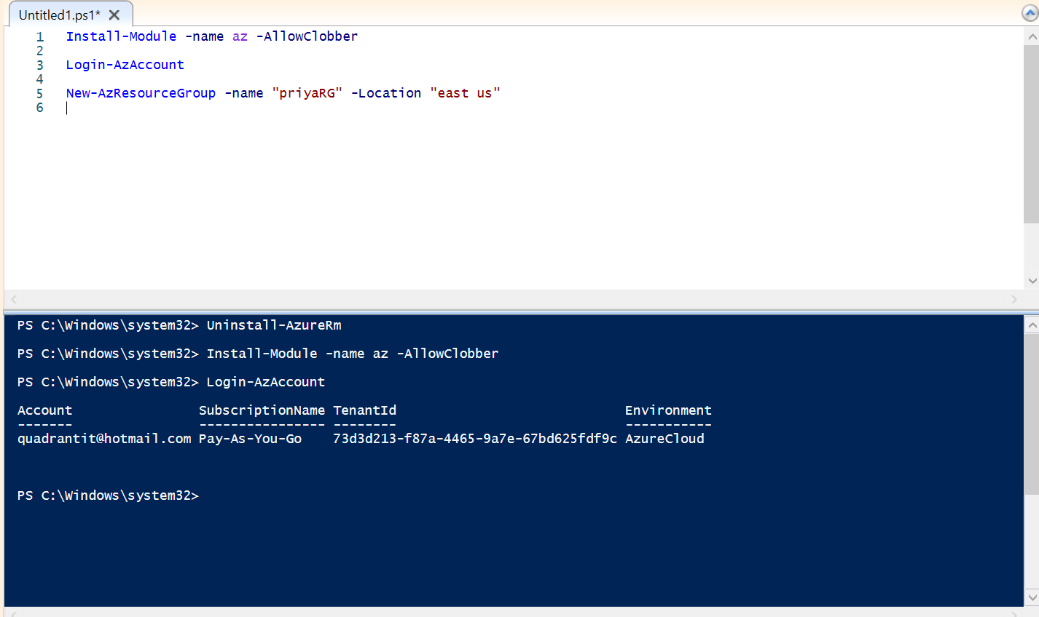

Resource group creation

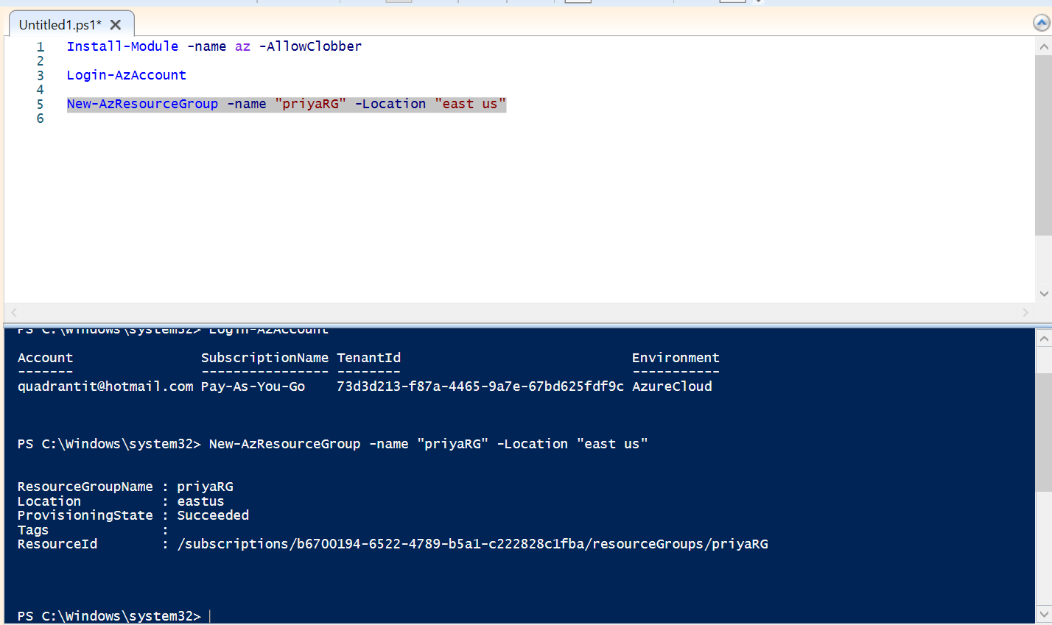

Storage account creation

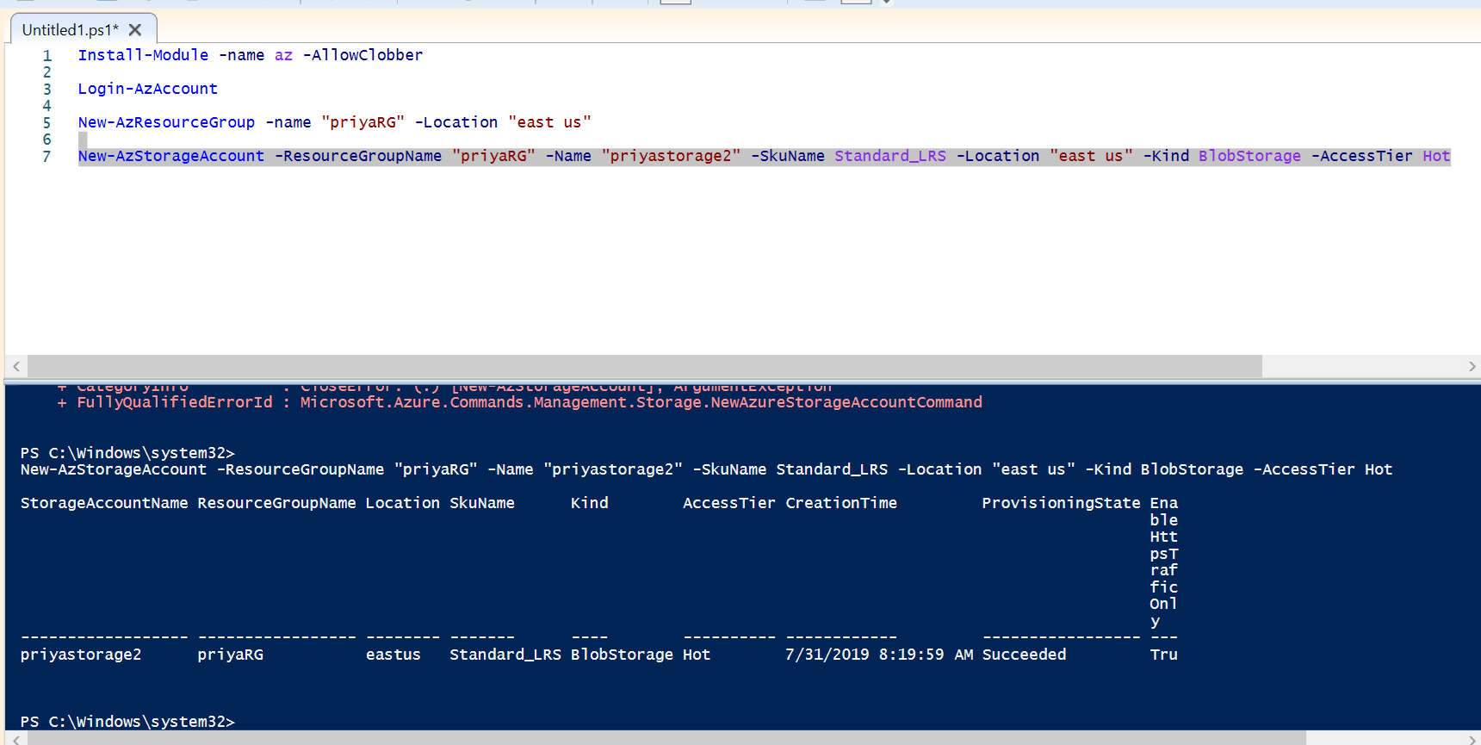

Virtual machine creation

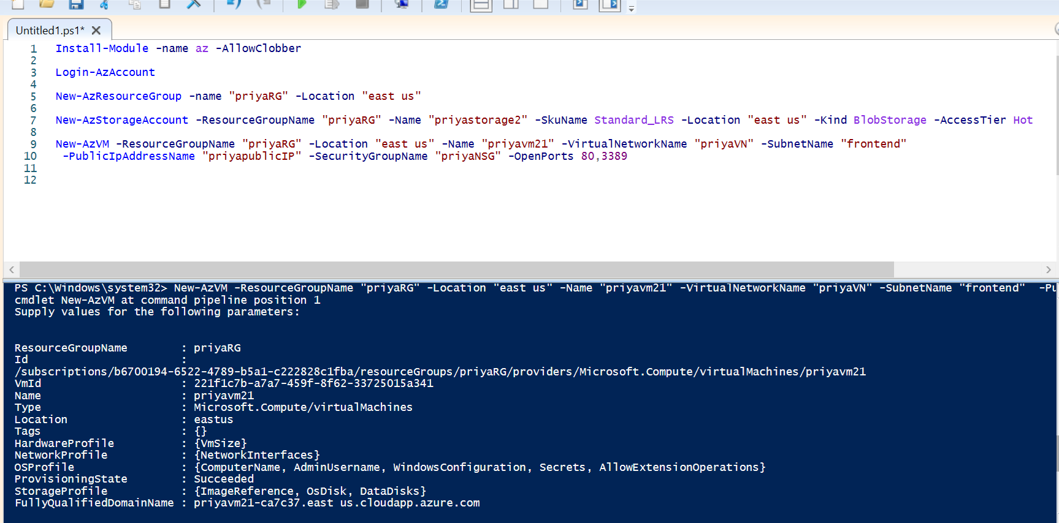

The first time you use Azure Backup, you must register the Azure Recovery Service provider in your subscription

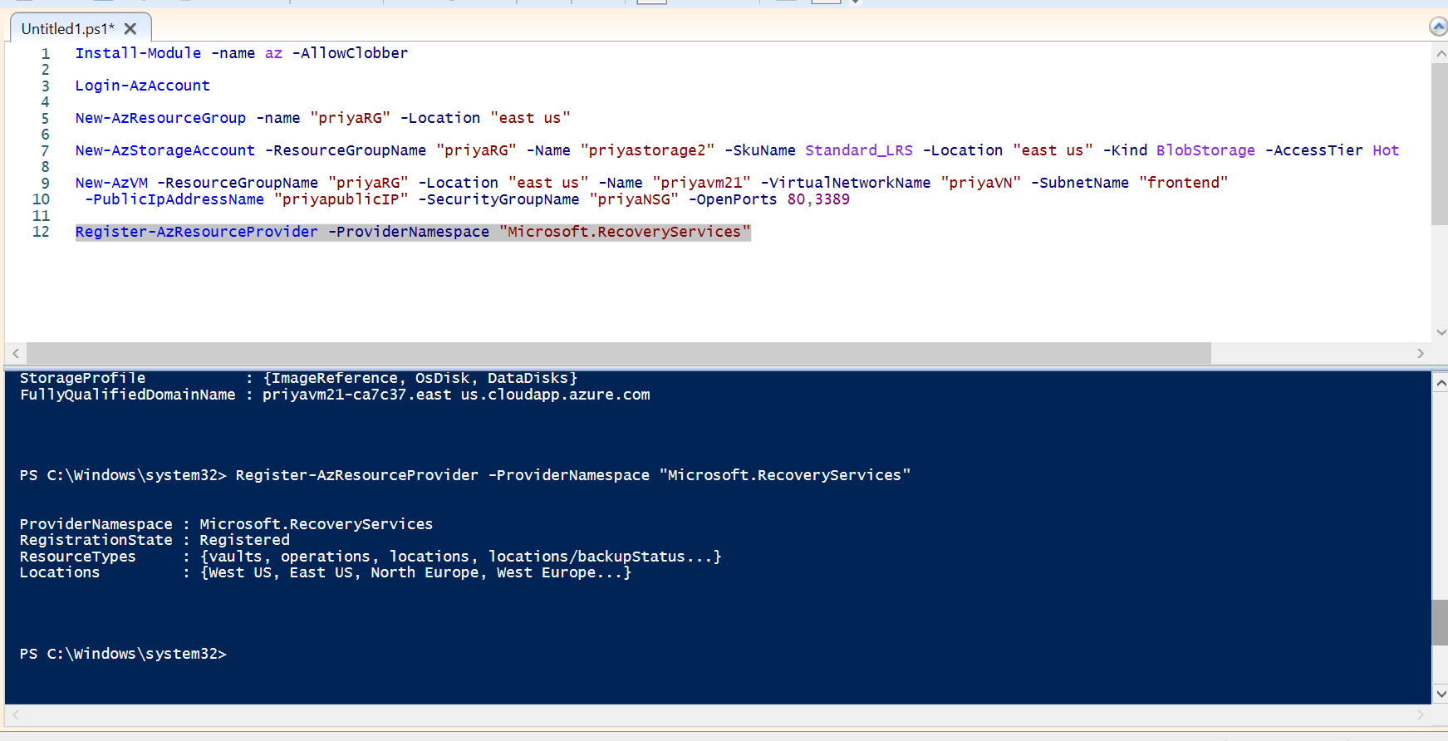

Recovery servicevault creation

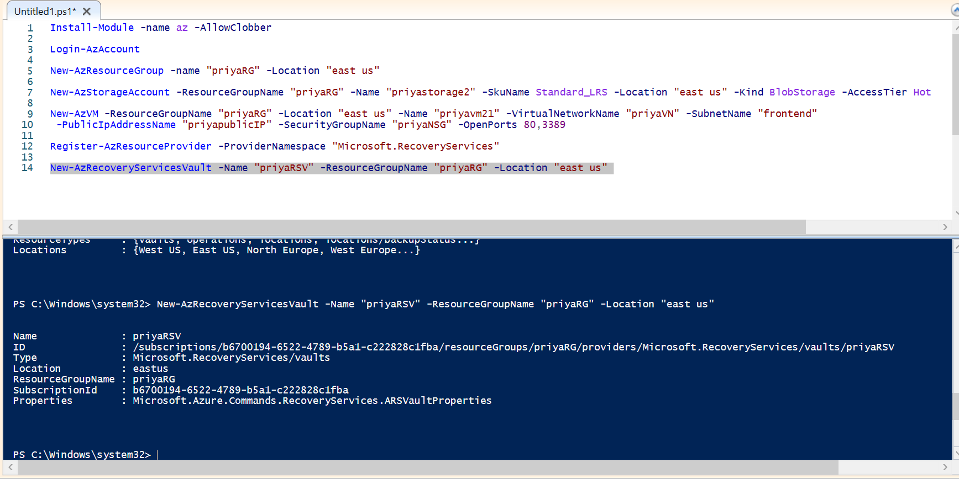

From azure portal

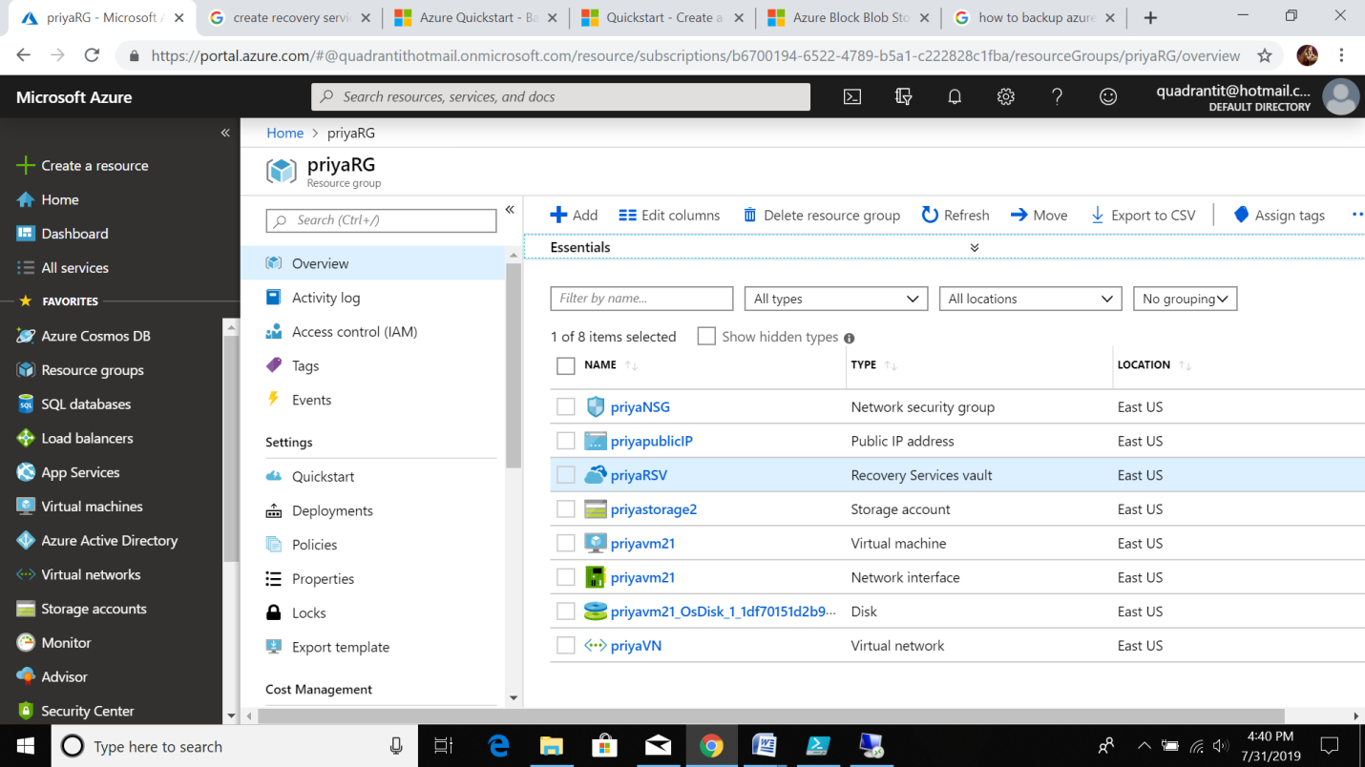

Now VM backup process

1.give backup goal -> Backup

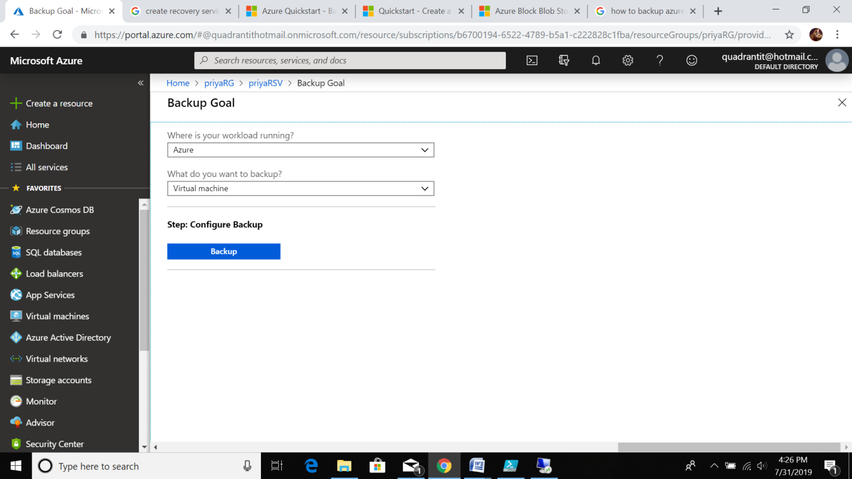

2.Create coustom backup policy these are steps

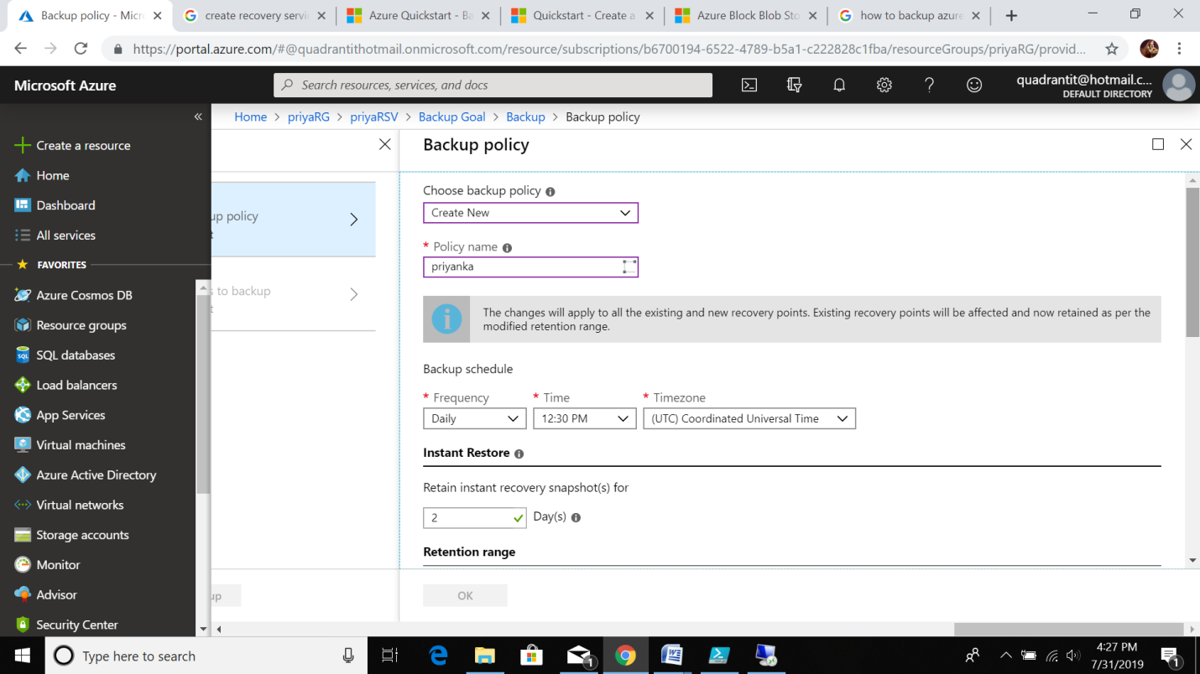

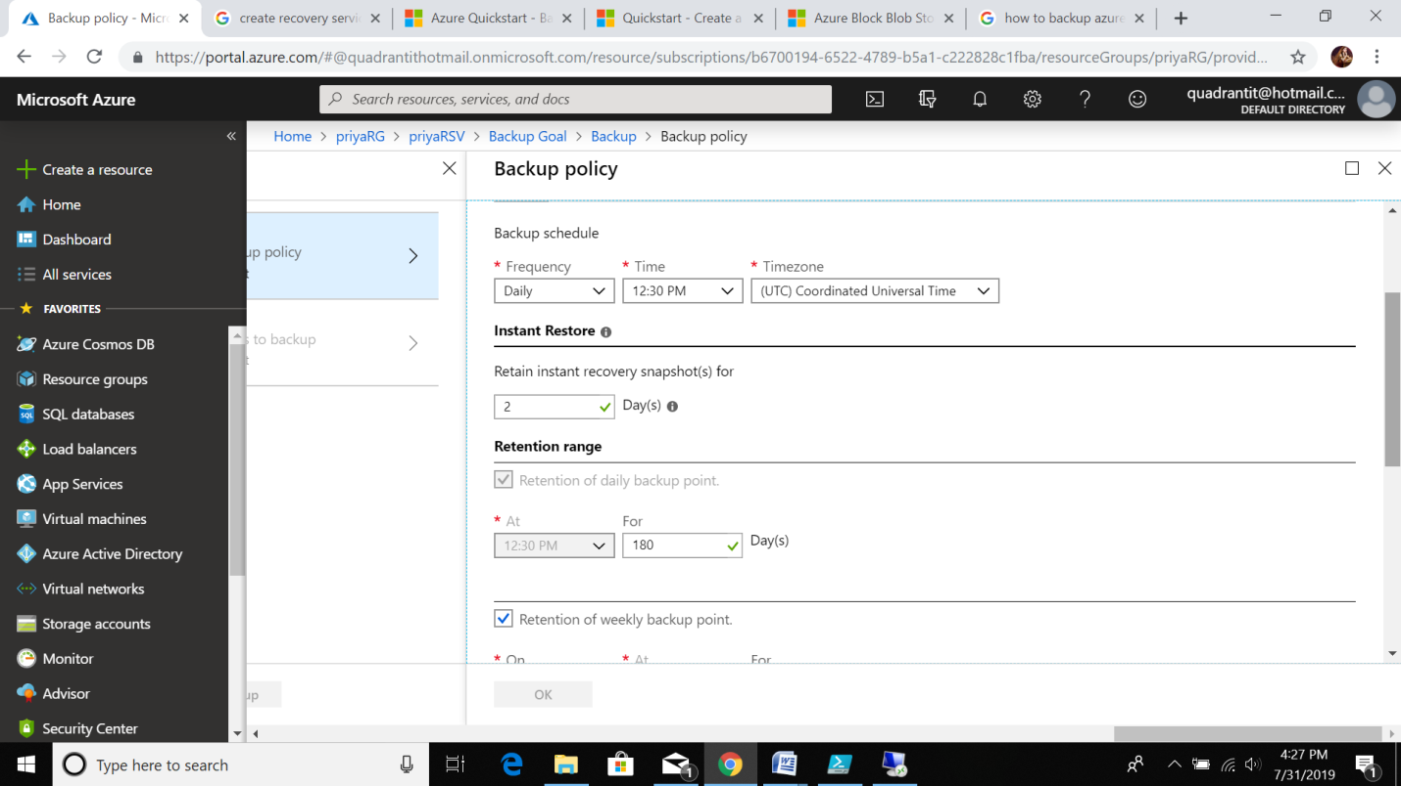

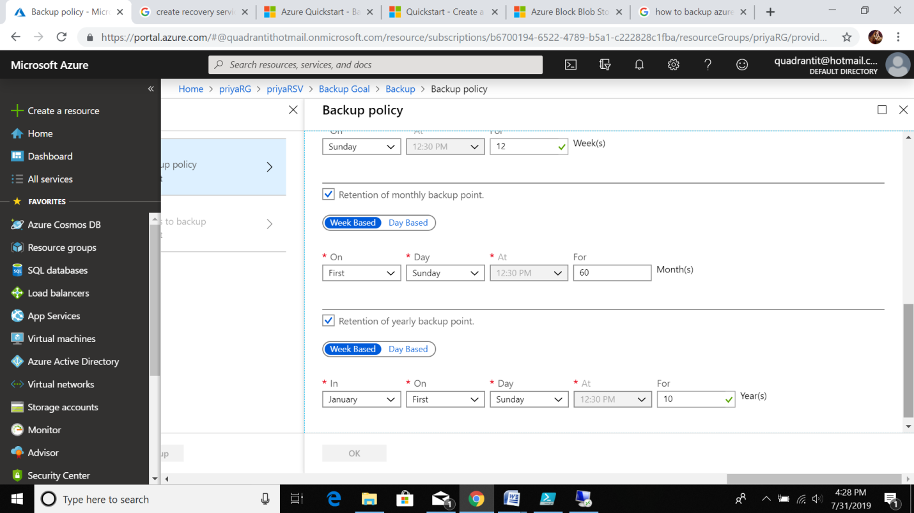

Click OK button -> this is my backpolicy

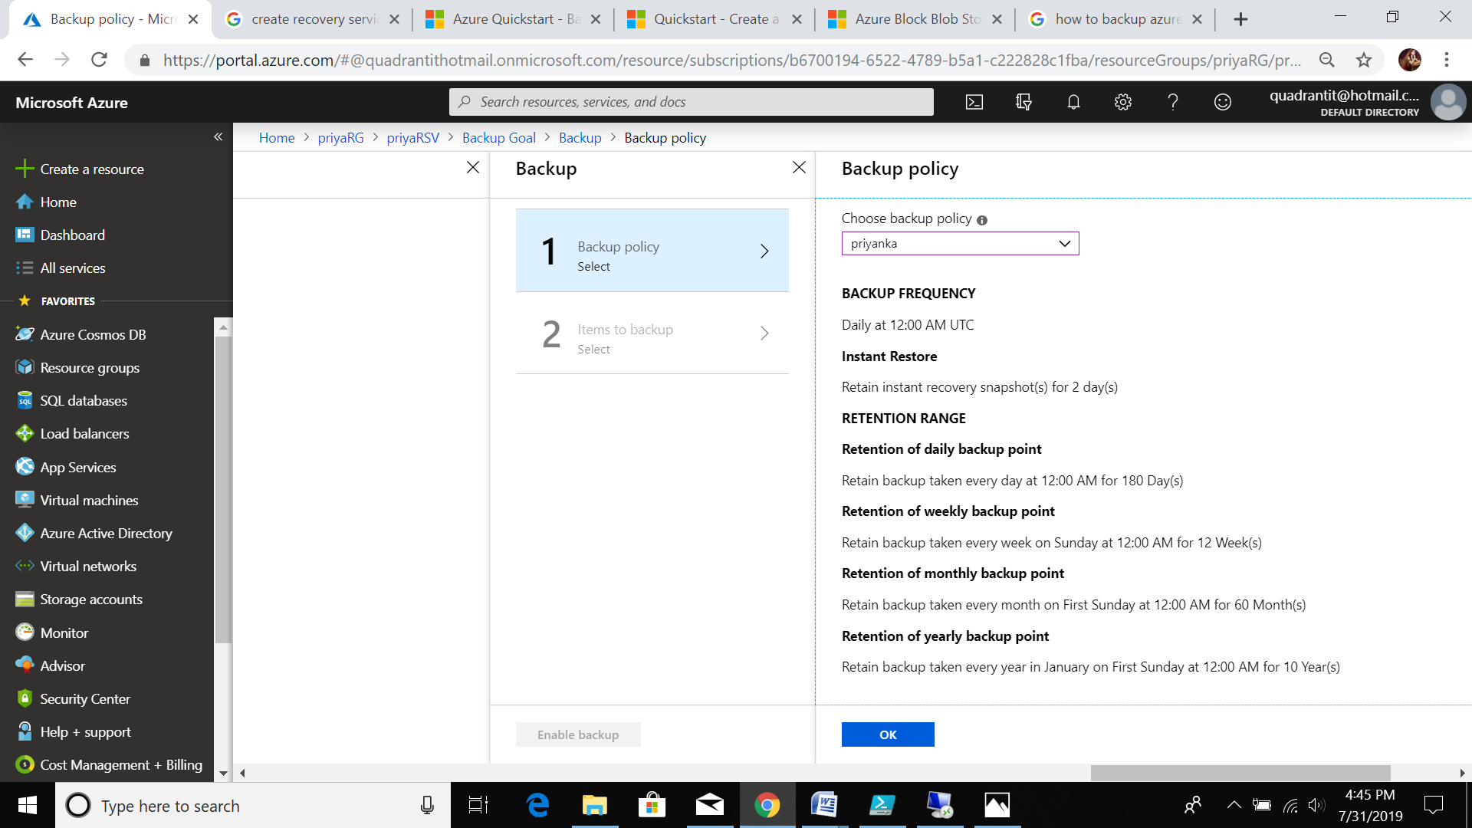

Home ->[priyaRG](https://portal.azure.com/) ->[priyaRSV - Backup items](https://portal.azure.com/) ->[Backup Items (Azure Virtual Machine)](https://portal.azure.com/) ->[priyavm21](https://portal.azure.com/)

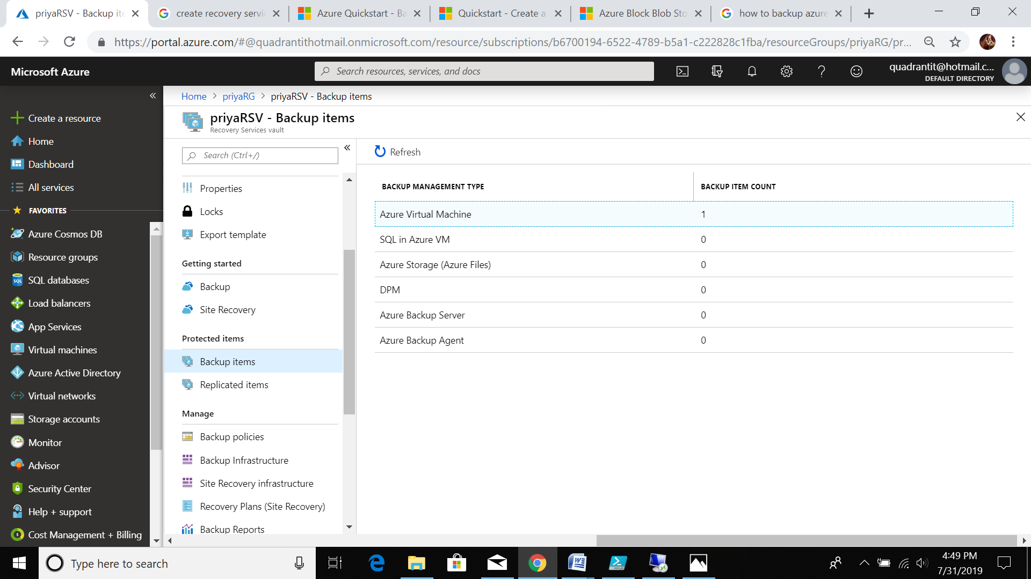

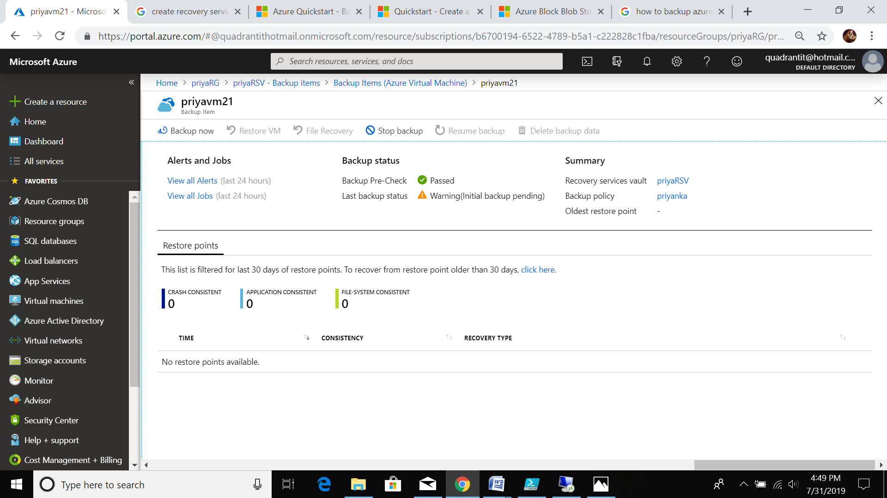

My backup is running..

Backup of VM completed

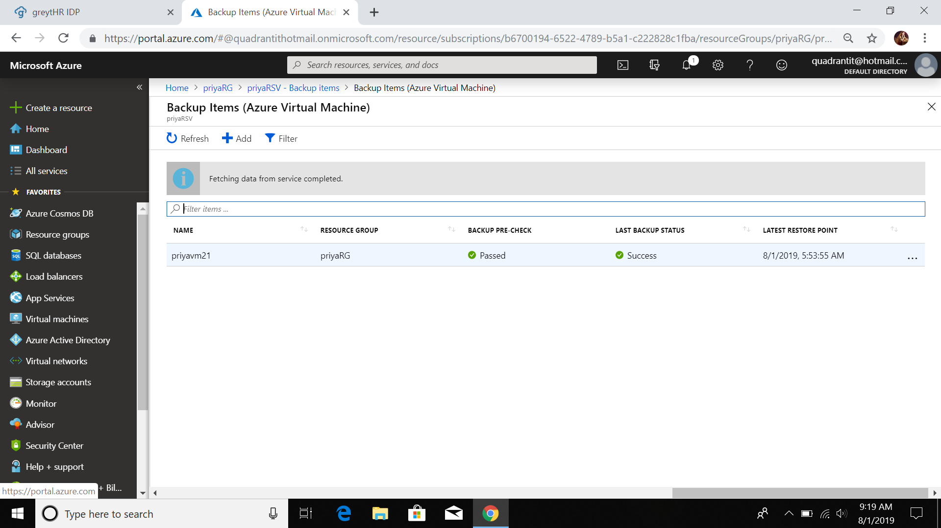

RESTORE OF VM

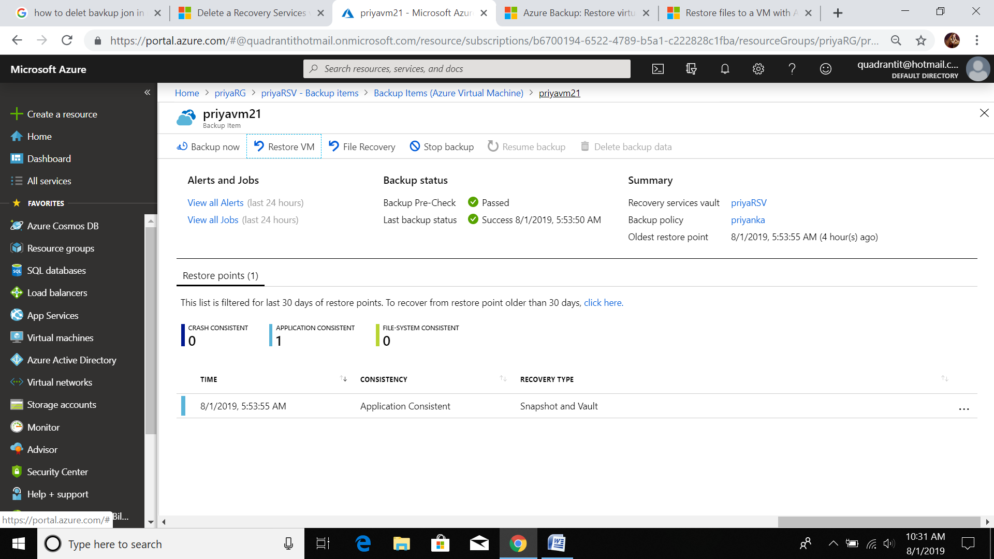

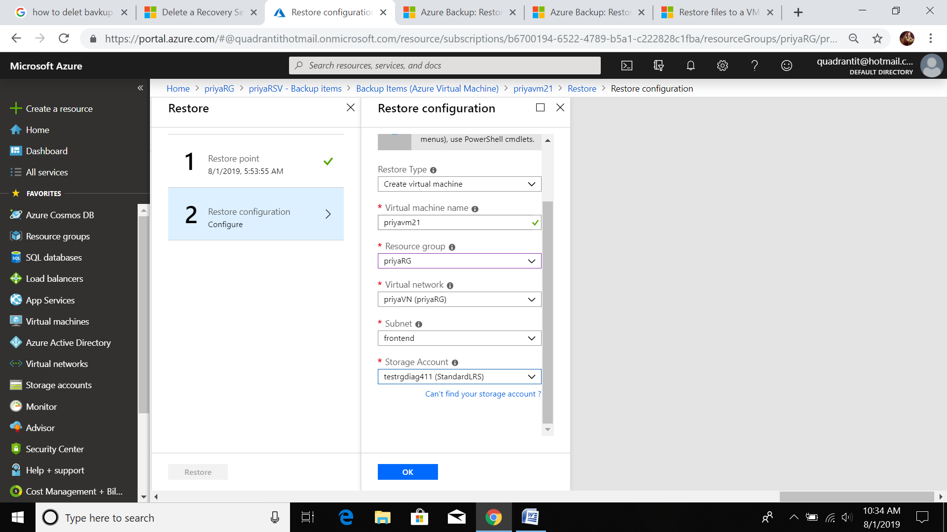

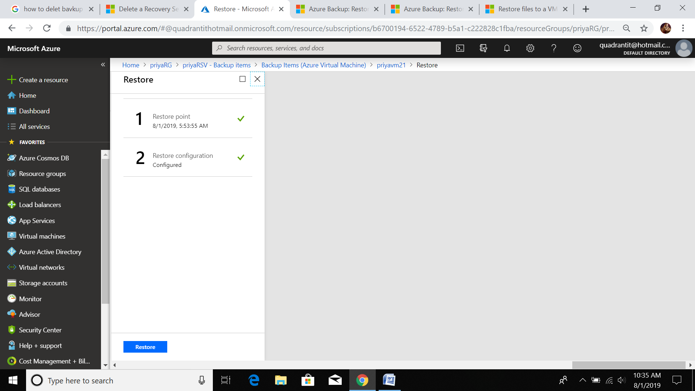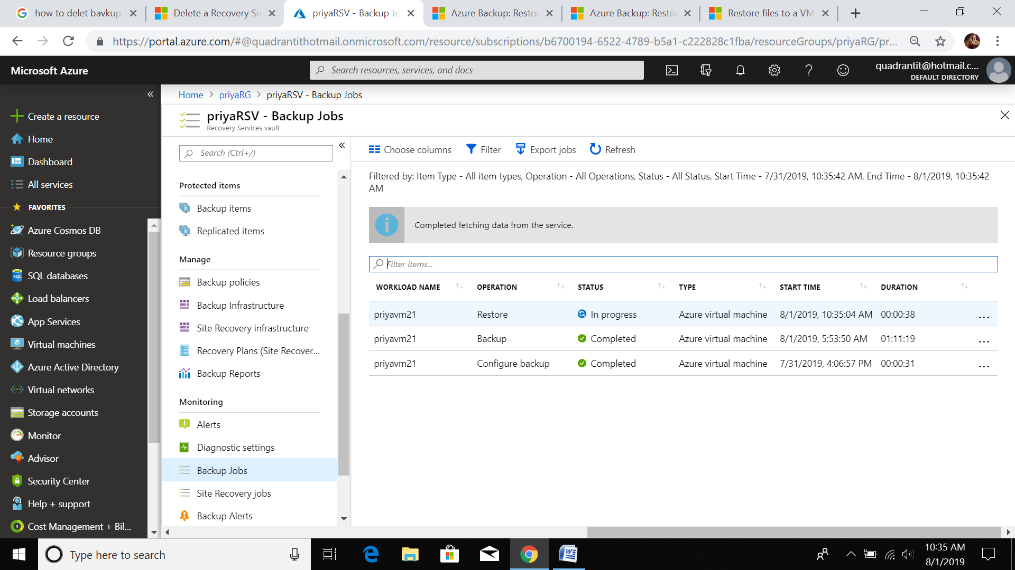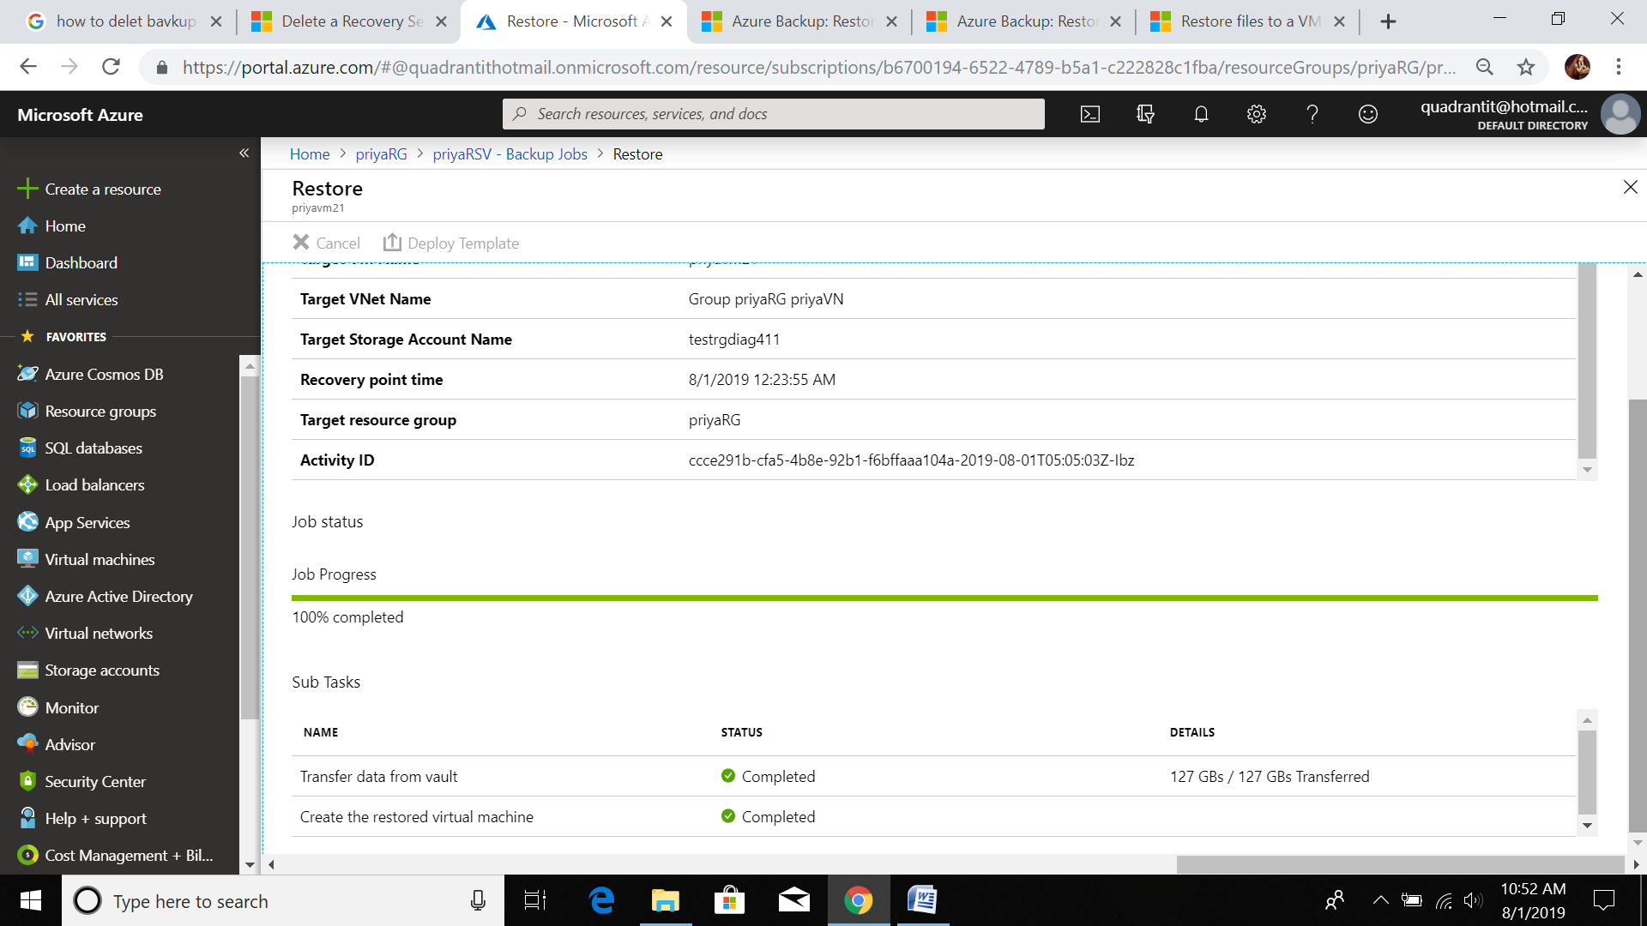

After all these steps .. VM restored sucessfully with our credentials

